TU821 Y2SEM1 PROGRAMMING
PROJECT DESIGN DOCUMENT

TASK:
DESIGN AND PROGRAM A
TASK MANAGEMENT SYSTEM

Oisín Lane
Ostap Badyuk
Oscar Tweed
TABLE OF CONTENTS
PROGRAM OVERVIEW 3
TASK LOGIC 4
DATA MANAGEMENT 5
USER INTERFACE 6
RESOURCES 7

PROGRAM OVERVIEW

We would start discussing our program with the technical requirements we were provided and assigned to. Our goal would be to implement a task manager in C++, while using the skills we acquired throughout the semester.
Technical requirements would be a:
- A console application for managing tasks with functionalities to add, edit, delete, and view tasks.
- It is supposed to have an:
- User login/logout
- Add new tasks with descriptions and deadlines
- Edit and delete tasks
- View tasks by status (e.g., completed, pending)
- Save tasks to a file for persistence

TASK LOGIC
The application layer

DATA MANAGEMENT
The persistence layer

USER INTERFACE
The presentation layer

The UI section of this system focuses on how the user interacts with the system. The UI presents menus, reads user choices, calls functions, and displays error messages.

The UI has responsibilities such as handling log in and sign up, displaying a main menu, allowing users to edit tasks, delete tasks, and add tasks, switching between users, and quitting the application.
Ui functions and Called functions:
UI Functions:
showLoginMenu ()
showMainMenu ()
viewTasks ()
addTasks ()
editTasks ()
deleteTasks ()
switchUser ()
logout ()
Called Functions:
User::setCurrentUser ()
User::getCurrentUser ()
User::userLoginUI ()
User::userSignupUI ()
TaskData::displayUserTasks ()
Task::createTask ()
Task::updateTaskName ()
Task:: updateTaskDescription ()
Task:: updateTaskDeadline ()
Task:: updateTaskStatus ()
Task:: deleteTask ()

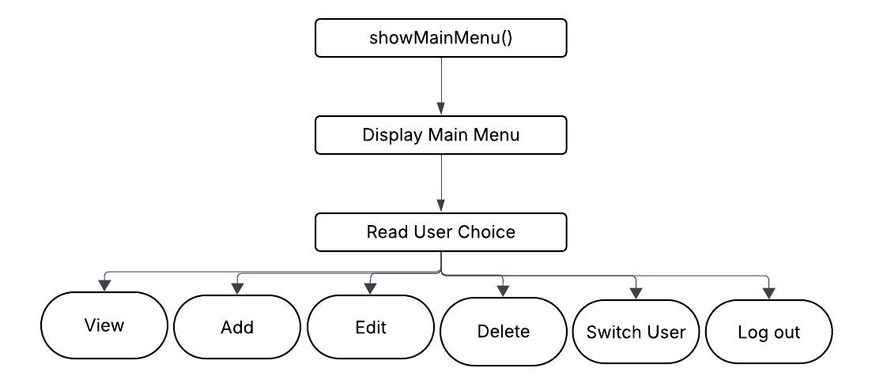
Log in menu flow: Main menu flow:
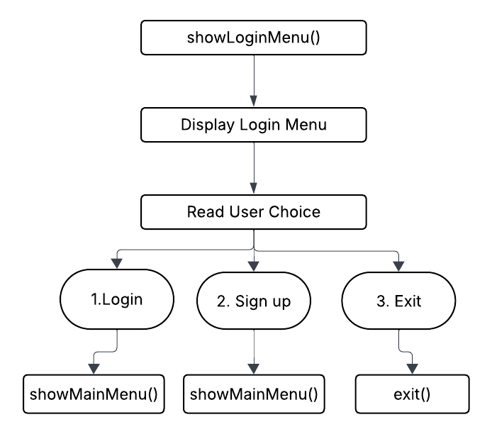

Both the login and main menu use a infinite loop to keep them open and prevent exiting without explicity choosing.
The buffer must also be cleared using the cin.ignore().

RESOURCES

